1st search: violet

|  |  |  |  |
| --- | --- | --- | --- |
| **First** | **Last** | **Middle** | **Comparison** |
| 0 | 10 | 5 | Violet>Indigo |
| 6 | 10 | 8 | Violet>Red |
| 9 | 10 | 9 | Violet=Violet  Return:true |
|  |  |  |  |
|  |  |  |  |

2nd search: green

|  |  |  |  |
| --- | --- | --- | --- |
| **First** | **Last** | **Middle** | **Comparison** |
| 0 | 10 | 5 | Green>Indigo |
| 0 | 4 | 2 | Green>Chartreuse |
| 3 | 4 | 3 | Green>Dark Brown |
| 4 | 4 | 4 | Green=Green  Return:true |
|  |  |  |  |

3rd search: yellow

|  |  |  |  |
| --- | --- | --- | --- |
| **First** | **Last** | **Middle** | **Comparison** |
| 0 | 10 | 5 | Yellow>Indigo |
| 6 | 10 | 8 | Yellow>red |
| 9 | 10 | 9 | Yellow>Violet |
| 10 | 10 | 10 | Yellow=Yellow  Return:true |
|  |  |  |  |

**Color array**:

|  |  |
| --- | --- |
| aqua | [0] |
| brown | [1] |
| chartreuse | [2] |
| dark brown | [3] |
| green | [4] |
| indigo | [5] |
| lavender | [6] |
| magenta | [7] |
| red | [8] |
| violet | [9] |
| yellow | [10] |

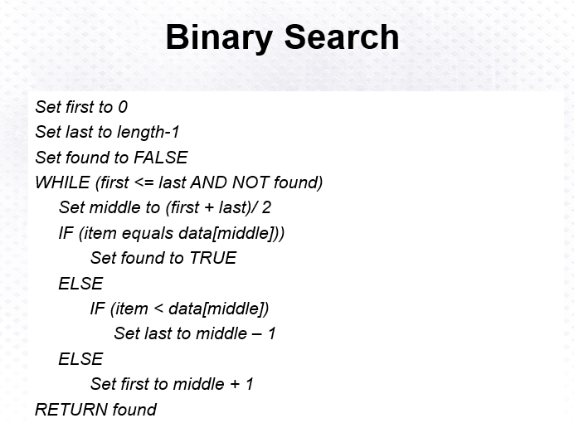

Above: Binary Search Algorithm

